TRIM TIP 02-04
Updated: 4/11/2014

Searching TRIM for HR (Personnel) Files
Audience: HRM staff with permission to view HR files
Purpose: The following is the easiest way to access digital personnel records whilst we are transitioning to the new system as part of the Digitisation of HR Files Project.
Corporate Records & Digitisation Services (CRDS) is back-scanning all parts of all files, and these will be titled
“Legacy File – Name of person”. All other documents which have been digitised will be titled individually.

Open TRIM Web Client | http://na-prd-trimweb/hptrimwebclient/  TIP: Problem logging into TRIM web client? Contact CARMS  (Uses Single Sign On so you will not be asked for your ID/password)
Search for the file | 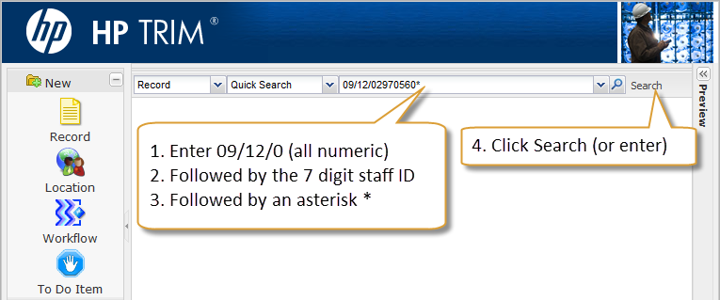
File number search results | This will return all files for the particular staff member. Any new documents recently received by CRDS will be in the latest part (if there are more than one part to a file).  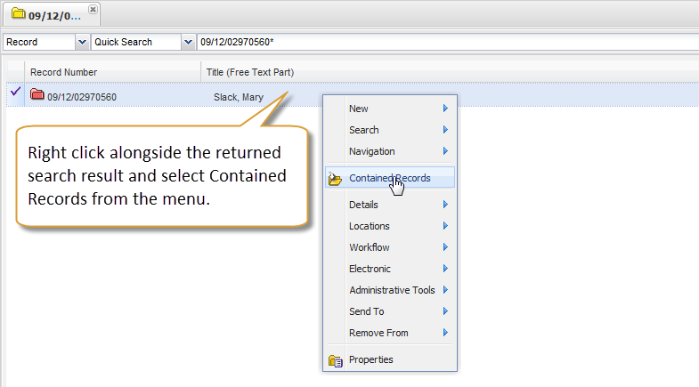
Contained documents | 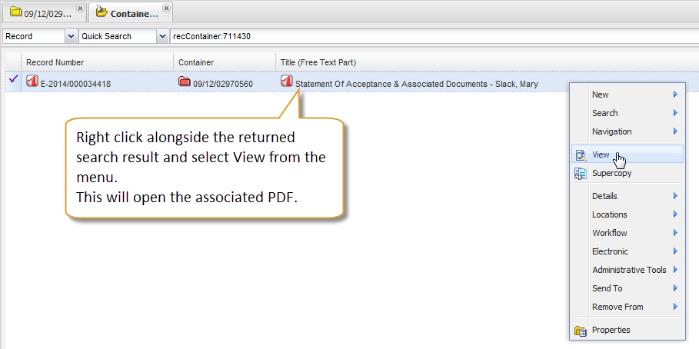  Note that the PDF will be text searchable for ease-of-use.
Multiple parts? | 